Coherence and cohesion

Coherence
The complex nature of coherence and cohesion offers grounds for a wide spectrum of interpretations. Halliday and Hasan (1976), and later Halliday (1985), see coherence as created by surface textual elements (e.g., identity and similarity chains). ‘Interactionalists’, such as van Dijk and Kintsch (1983), define coherence as a cognitive interaction between the reader and the textual elements. According to de Beaugrande and Dressler (1981), coherence refers to “how the configuration of concepts and relations which underlie the surface text, are mutually accessible and relevant” (pp. 3-4). More recently, coherence was defined by Crossley and McNamara as “the understanding that the reader derives from the text” (2010, p. 984), its main factors being prior knowledge, textual features, and reading skills (McNamara, Kintsch, Songer, & Kintsch, 1996).

Cohesion
Halliday and Hasan (1976) maintain that cohesion is “the relation of meaning that exists within the text, and that define it as a text” (p.4). According to their interpretation, cohesion occurs “where the interpretation of some element in the text is dependent on that of another. The one presupposes the other, in the sense that it cannot be effectively decoded except by recourse to it.”(ibid.). Thus, cohesion largely (but not exclusively) contributes to coherence.
De Beaugrande and Dressler (1981) see cohesion as one of their six criteria of textuality: cohesion, coherence, intentionality, acceptability, situationality and intertextuality. They claim that cohesion is indispensable for a text to be a text. Enkvist (1990) and Hoey (1991) also see cohesion as a property of text and therefore being objectively observable. Hoey’s definition is perhaps a little blurred because he concentrates on the textual roles of sentences: “Cohesion may be crudely defined as the way certain words or grammatical features of a sentence can connect that sentence to its predecessors (and successors) in a text” (1991, p. 3). The nature of cohesion might be better captured instead focusing on the text, as “[c]ohesion refers to the presence or absence of explicit clues in the text that allow the reader to make connections between the ideas in the text” (Crossley & McNamara, 2010, p. 984). Such explicit clues can be “overlapping words and concepts between sentences” or connectives such as therefore or consequently (ibid.).
Widdowson (1978) takes a different approach towards cohesion. He argues that cohesion is neither necessary, nor sufficient for coherence. His famous example for this is the following conversation (p. 29):
A: That’s the telephone.
B: I’m in the bath.
A: O.K.
Even though this short exchange is an example of spoken discourse where coherence can be detected across turn boundaries (what A says /what B says /what A says), it still demonstrates that coherence can exist without the explicit markers of cohesion. As Widdowson puts it: coherence is by nature interactive, while cohesion is within discourse, which is by nature static (as cited in Fulcher, 1989, p. 148).

Cohesive harmony
Halliday and Hasan (1976) in their analytic model identify the semantic and lexico-grammatical elements which are responsible for creating texture in English. The five categories are reference, substitution, ellipsis, conjunction, and lexical cohesion, shown in Table 1 with examples. The first four are mainly grammatical categories, and as such, they are fairly straightforward. The category of lexical cohesion seems more problematic, with its two subclasses: reiteration and collocation. The cohesive relation between any two of these lexical elements is called a cohesive tie. These ties form cohesive chains, and the interactions among chains further cause global “cohesive harmony” (Hasan, 1984) in text.

Cohesion by Coh-Metrix,
all explanations from the Coh-Metrix manual
(McNamara, Louwerse, Cai, & Graesser, 2005)
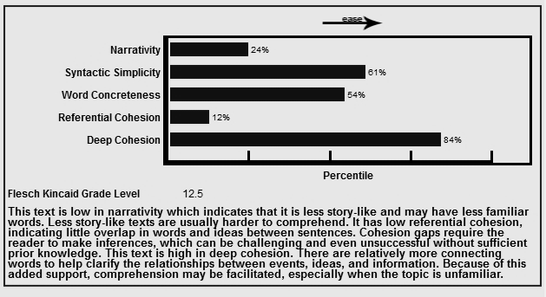
Referential cohesion refers to overlap in content words between local sentences, or co-reference. Coh-Metrix measures for referential cohesion vary along two dimensions. First, the indices vary from local to more global. Local cohesion is measured by assessing the overlap between consecutive, adjacent sentences, whereas global cohesion is assessed by measuring the overlap between all of the sentences in a paragraph or text. Latent Semantic Analysis (LSA; Landauer et al., 2007) provides measures of semantic overlap between sentences or between paragraphs. Coh-Metrix 3.0 provides eight LSA indices. Each of these measures varies from 0 (low cohesion) to 1 (high cohesion).
Example:
Text 1: The field was full of lush, green grass. The horses grazed peacefully. The young children played with kites. The women occasionally looked up, but only occasionally. A warm summer breeze blew and everyone, for once, was almost happy.

Text 2: The field was full of lush, green grass. An elephant is a large animal. No-one appreciates being lied to. What are we going to have for dinner tonight?

In the example texts printed above, Text 1 records much higher LSA scores than Text 2. The words in Text 1 tend to be thematically related to a pleasant day in an idyllic park scene: green, grass, children, playing, summer, breeze, kites, and happy. In contrast, the sentences in Text 2 tend to be unrelated.

Lexical cohesion was defined by Hoey (1991) as “the dominant mode of creating texture”, because it is “the only type of cohesion that regularly forms multiple relationships” in text (p.10), making it unique among cohesive devices. His empirical investigation indicated that lexical cohesion accounted for more than forty percent of the total cohesion devices in the various texts he studied (1991). In a more recent corpus linguistic study it was claimed that nearly fifty percent of a text’s cohesive ties consist of lexical cohesion devices (Teich & Fankhauser, 2004), thus making it the most pronounced contributor to semantic coherence.

Three paragraphs of a sample compare/contrast essay indicating some of the lexical repetition links (adjectives/adverbs). Text: Oxford Advanced Learners’ Dictionary 8th ed. (OUP, 2008)

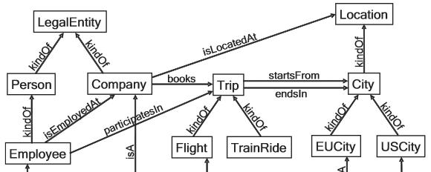
Illustration of a semantic network for business trips (based on Grimm, Hitzler, & Abecker, 2005, p. 39) Nouns represent the concepts (in rectangles), the arrows specify the relationships between the concepts.
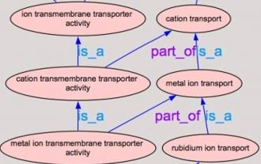
Visual representation of a gene ontology within the field of biology (based on the online training material of the European Bioinformatics Institute.

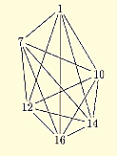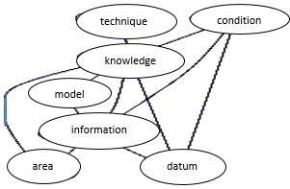
A net and a chain of lexical repetition in two studies (Hoey, 1991, p. 81; and Barzilay & Elhadad, 1999, p. 116)

Educational application
The concepts of coherence, cohesion and lexical repetition are often mentioned in academic course books as aspects of writing which need caution and attention. As an illustration, Cresswell’s (2007) hook-and-eye technique is mentioned here, which teaches writers how to self-check textual cohesion in their drafts. The technique, which Creswell credits to Wilkinson (1991), connects words and phrases referring to the same idea by drawing hooks and eyes across sentences. The words can be followed further in a chain-like manner to highlight progression of topic on the discourse level, in overarching paragraphs. The following illustration is an example from Creswell’s book (2007, p.59) where he offers strategies for writing up research.
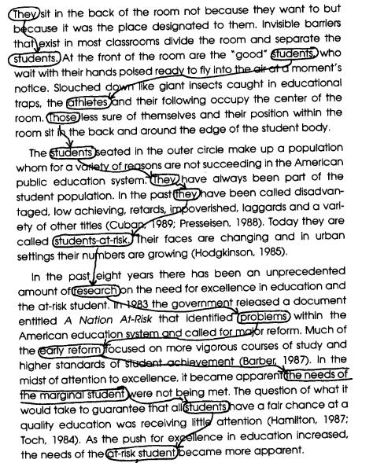
The hook-and-eye technique connecting major thoughts on discourse level (in Creswell, (2007, p. 59)
Creswell (2007) describes this text as highly coherent because these connections can easily be made. He suggests that it is not necessary for this writer to add transitional phrases here to establish a clearer logical sequence. Even though he does not mention lexical repetition as such, the chain of reiterations, synonyms, superordinate terms used with pronouns clearly show the distinctive discourse organizational role of repetition.
Another of Creswell’s (2007) suggestions is the use of consistent terms throughout the text. He also adds that it is advisable to refrain from using synonyms for these terms. It is important to note that this is a more useful recommendation than the rather simplistic advice for students in various other guides to avoid repetition in general. He also mentions staging of new information and foreshadowing ideas as building coherence and readability of texts.

