CURRICULUM VITAE
BRIDGING PROGRAMME YEAR 2017

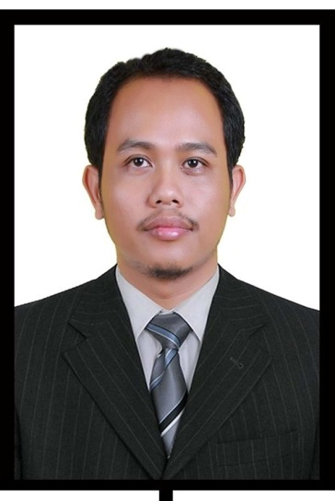
PERSONAL DATA
Academic Title/Degree : Master of Arts
First Name(s) : Dedy
Family Name(s) : Subandowo
Gender : Male
Previous or Maiden Name(s) :
Email Address : subandowo.dedy@hallgato.ppke.hu
dedy.ummetro@yahoo.com
Date of Birth : June 15, 1986
Place of Birth : Sambikarto
Country of Birth : Indonesia
Name of Spouse : Juliyati
Profession of Spouse : Housewife
Number of Children : 1
Age of Child/Children : 7 years old
Citizenship(s) : Indonesian
Skype : dedy.subandowo
https://scholar.google.com/citations?user=Hk5EB-wAAAAJ&hl=id

Google Scholar :

Orcid id : https://orcid.org/0000-0002-9174-2557
Research Gate : https://www.researchgate.net/profile/Dedy_Subandowo

I am currently pursuing a doctoral degree in English Applied Linguistics at Pazmany Peter Catholic University (PPCU) in Hungary. My studies are funded by the Hungarian Government through the Stipendium Hungaricum Awards program. My research project focuses on Indonesian students' experiences in English academic writing in a non-native English-speaking environment.

Address
Abroad Address : 1085, Baross utca No. 43,
Budapest, Hungary
Permanent Address : Refika Residence, Jl. Mandiri 4 Desa Mulyojati
RT/RW 05/22 Metro Barat, Metro, Lampung.
City : Metro
Postal /ZipCode : 34125
Country : Indonesia

Current Academic Employment
Name of Employer (university/institution) : Muhammadiyah University of Metro,Lampung
Your Position : Fulltime Lecturer
Describe your Current Position : Senior Lecturer at English Education Study
program
From : 2014
To (estimated) : 2048

Academic Degree (s)
Degree : Master
Academic Titel : Master of Arts
Field of Study : Linguistics
Faculty : Humanities and Arts
Beginning of your Studies : 2009
Date of Graduation : July 27
Year of Graduation : 2011
Duration of Study in Years : 2 Years
Name of University : Gadjah Mada University
City : Yogyakarta
Country : Indonesia
Thesis/Dissertation : Thesis
If yes,Title of Thesis/Dissertation : Negative Affixes in English
Name of Supervisor : Prof. Dr. Soepomo Poedjosoedarmo
Function of Supervisor (institute,department): Sanata Dharma University, English
Department
International Experiences

No | Year | Award
1 | 2019 | Stipendium Hungaricum Scholarship – Doctoral Degree Study
2 | 2019 | ASEAN Access Grants by CamTESOL Conference, Cambodia
3 | 2018 | CamTESOL Research Grant by IDP-Education of Cambodia
4 | 2017 | Bridging Program in Tunghai University by Ministry of Higher Education and institution of Indonesia (Ristekdikti) in Taiwan
5 | 2016 | International Course in Linguistics for Endangerd Language Documentation Program by SOAS University of London and Udayana University in Bali, Indonesia

Research Interest
My research concerns are in the fields of applied linguistics and language pedagogy, specifically in the areas of academic writing, L2 English academic writing, academic discourse, English as a medium of instruction in L2 settings, and ESL/EFL writers.

Academic Talk
No | Date | Conference name | Title
1 | 21st June 2022 | The Doctoral School conference at Pazmany Peter Catholic University | Strategies in English academic writing: Indonesian graduate students’ experiences at Hungarian universities
2 | 19th April, 2022 | National Webinar on Education and ELT “Hybrid Learning in Education and ELT” Organized by the English Education Study Program, Muhammadiyah University of Metro, Metro, Lampung, Indonesia | Intelligibility and Comprehensibility in L2 Phonology Acquisition
3 | 26th January 2022 | The Doctoral School conference at Pazmany Peter Catholic University | Indonesian graduate students’ L2 English academic writing strategies: Using interviews as a research method
4 | 9-11th September, 2021 | The 67th TEFLIN International Conference  and The 9th the International Conference on English Language and Teaching (ICoELT), Padang, Indonesia | A Global Perspective of L2 English Academic Writing in a Non-Native English-Speaking Environment
5 | 19-20th April, 2021 | 28th (Online) Congress of Hungarian Applied Linguistics by the Association of Hungarian Applied Linguists and Language Teachers (MANY), Veszprem, Hungary | Linguistic Features of Indonesian Graduate Students’ L2 English Academic Texts: A Comparative Study
6 | 26th January, 2021 | The Doctoral School conference at Pazmany Peter Catholic University | A Comparison of Linguistic Features in Indonesian Graduate Students’ L2 English Academic Writing in Hungarian Higher Education
7 | 4-5th December, 2020 | International Diversity in Teacher and Higher Education Research in the 21st Century: Insights from Doctoral Students, Supervisors, and Doctoral School Leaders – ELTE, Budapest, Hungary | Challenges in English Academic Writing: Indonesian Graduate Students’ Experiences in Hungarian Higher Education
8 | 23rd June, 2020 | The Doctoral School conference at Pazmany Peter Catholic University | Issues in L2 English Academic Writing
9 | 30th January, 2020 | The Doctoral School conference at Pazmany Peter Catholic University | Challenges in Academic Writing: A Mixed Method Study of Indonesian Graduate Students in a Non-Native English-Speaking Environment

