The Committee of National Seminar on Education and ELT
”Hybrid Learning in Education and ELT”

hosted by
English Education Study Program
University of Muhammadiyah Metro
www.pbiummetro.ac.id

Head of the Scientific Committee
Drs. Partono, M.Pd
(The Dean of Education Faculty)

Head of Organizing Committee
Refai, M.Pd

Members
Amirudin Latif, M.Pd
Aulia Hanifah Qomar, M.Pd
Eva Faliyanti, M.Pd.BI
Yasmika Baihaqi, M.Pd.Bi
Fenny Thresia, M.Pd
Syaifudin Latif Darmawan, M.Pd
Fitri Palupi Kusumawati, M.Pd.BI
Drs. Bambang Eko S, M.Pd
Dedy Subandowo, M.A
Arif Hidayat, M.Kom

Metro, February 13, 2022
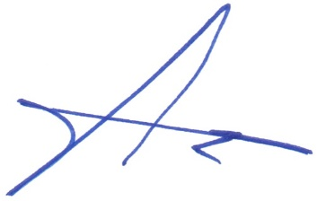

Drs. Partono, M.Pd.
NIP. 19660413 199103 1 003
(The Dean of Education Faculty)

