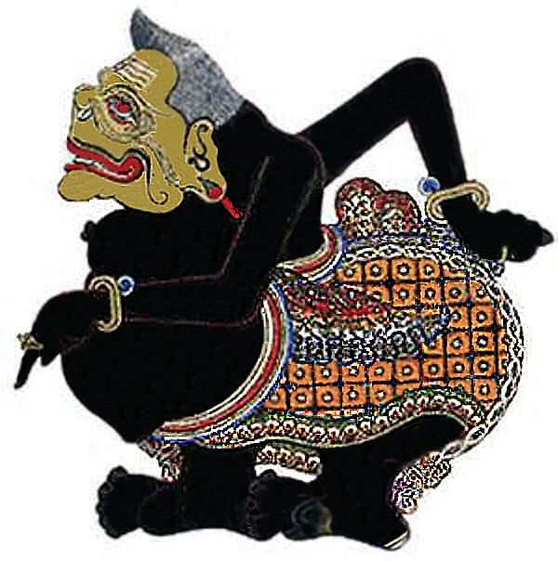
The Philosophy of Semar

Semar is a prominent figure in Javanese shadow puppetry, also known as wayang kulit (a shadow play). Wayang kulit is a traditional form of storytelling that combines elements of puppetry, music, and dance.

Semar is a clown-like character and one of the central figures in wayang kulit performances. He is often depicted as a portly, wise, and humorous character with a unique appearance, including a large nose, bulging eyes, and a big belly. Semar is considered to be the father of the Panakawan, a group of servant characters that accompany the main heroes in wayang stories.

In Javanese philosophy, Semar represents several significant concepts and values. Here are a few key aspects of Semar's philosophy:

- Wisdom and guidance: Semar is revered as a wise and insightful character. He often provides guidance, advice, and moral teachings to the main heroes in the story. Semar's wisdom is seen as essential for navigating life's challenges and making ethical choices.

- Humility and selflessness: Semar embodies humility and selflessness. Despite being a powerful figure, he willingly takes on the role of a servant. His selflessness serves as a reminder of the importance of putting others before oneself and maintaining a humble attitude.

- Balance and harmony: Semar represents the concept of balance and harmony in Javanese philosophy. He is associated with the union of opposing forces, such as good and evil or light and darkness. Semar's presence in wayang kulit performances helps restore equilibrium and resolve conflicts.

- Spiritual and mystical significance: Semar is often regarded as a mystical and spiritual figure. He is sometimes seen as a deity or a divine messenger, carrying esoteric knowledge and connecting the earthly and spiritual realms. In this context, Semar embodies the link between humanity and the divine.

