Topics and tasks
- Discussing HW
- Types of academic genres, types of texts
- The consequences of the intended audience
- Syntactic features of academic discourse
  - Types of clauses
  - Passive voice
  - Lexical density
  - Complex noun phrases
  - Nominalisation
  - Information packaging
- Lexical features of academic discourse
  - Academic words
  - CEFR level
  - Subject-specific vocabulary
  - Academic collocations
- Textual, contextual (situational), critical approaches in analysing discourse

Relative clauses: restrictive, non-restrictive and reduced relative clauses

- During the last couple of decades, two dramatic events have fundamentally changed the basis on which universities conduct tertiary education. (Educ. Sci. 2019, 9, p. 267)
- It is important to avoid confusion between this idea, which necessarily involves awareness, and the more general notion of a comparison between input and interlanguage. (Second L. Research 14,2, 1998, p. 104)
- Doubts as to the proper division of property at death, as well as rights between partners living together, were resolved by having legal rules prescribing a formula. (uefap.com)

Passive voice
- Better results are expected soon. (uefap.com)
- This type of computer is now being manufactured in Korea. (uefap.com)
- The question of what constitutes effective teaching has been researched for decades.
- For example, instructional clarity is a dimension of instructional delivery but also can be viewed as a consequence of learning environment. (Stronge, J. of T. Edu. 62(4))

Nouns:
Table: Swales, J. (2004) Research Genres, Cambridge: CUP.

Noun phrases: 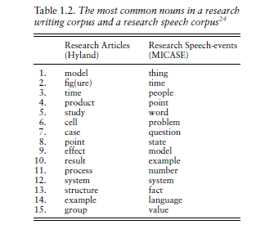
complex noun phrases with premodification, postmodification, or both

determiner | premodifier | head | postmodifier
a | complicated | solution | to the problem

Nominalisation: using nominalisation will make a text more …………………. .
- This information enables us to formulate precise questions. → This information enables the formulation of precise questions.
- All organisms reproduce and sometimes when they reproduce, the children vary. This is an important characteristic of life. → Reproduction with variation is a major characteristic of life. Without reproduction, life would quickly come to an end.

HW Rewrite the sentences by changing the underlined verbs into nouns. Also change the grammatical structure around this new noun.
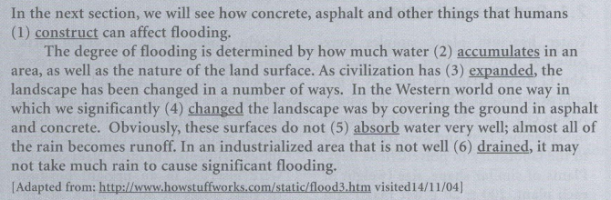

- In the next section, we will see how concrete, asphalt and other human construction can affect flooding.
- The degree of flooding is determined by the ……………. of water in an area, as well as the nature of the land surface.
- With the ………………………………., the landscape has been changed in a number of ways.
- In the Western world, significant ……... ………. were made by covering the ground with asphalt and concrete.
- Obviously, the ……………... of these surfaces is very low; almost all of the rain becomes runoff.
- In an industrialized area that lacks good …………………….it may not take my train to cause significant flooding.
Based on Hamp-Lyons, S. & Heasley, B. (2006). Study writing. 2nd ed. Cambridge: CUP.

Anaphoric nouns = general nouns (discourse organisational nouns / shell nouns) for continuing ideas with “the, this, these, such”

For example, instructional clarity is a dimension of instructional delivery but also can be viewed as a consequence of the learning environment. This overlapping nature of teaching will always hold true when we attempt to deconstruct it into discrete categories.

These nouns in the table are very likely anaphoric nouns in research studies.

FOR THINGS THAT HAPPEN | FOR THINGS THAT PEOPLE DO | FOR THINGS THAT PEOPLE SAY OR WRITE | FOR THINGS THAT PEOPLE THINK
problem | action | claim | idea
issue | response | criticism | opinion
situation | move | request | belief
circumstances | habit | offer | attitude
crisis | task | statement | reaction
development | tendency | generalisation | view
event | practice | objection
incident | conduct
occurrence | behaviour
 | achievement

HW Which noun from the list below can continue the idea best from the first sentence?

change / progress / discovery / risk / link / lack / increase / requirement / prediction / assistance

- The condition of the patient has improved in the last 24 hours. This ………….
- The public’s opinion of the president is more negative than it was 6 months ago. This ……………
- In 1960, Researchers found the remains of 10th-century Norwegian houses in Canada. This ………….
- Some medical experts believe that there may be a connection between heart disease and bacteria. This ………
- The chance of catching malaria is especially high in some tropical countries. This ……….
- To graduate from that University you need to take at least three computer classes. This ……………
- In the 1970s, researchers said that people today would work only 4 days a week. This …………….
- In many poorer countries there are not enough doctors or other health workers. This ……
- Wealthier nations need to help poorer countries develop their healthcare systems. This ………... .
- The cost of healthcare rose by 14% last year. This ………..

HW From the list below, find the noun that best continues an idea from the first sentence of each item. The words in bold will help you. Not all words are necessary!

tendency / move / failures / attempts / views / incident / attitude / statements / circumstances / achievement

- The government believes that the education system is weak but that testing students every year will improve it. These ……………. are not shared by many teachers and parents.
- The first three tests of the new plane have been unsuccessful. These ……………… will slow development of the aircraft.
- Parents tend to avoid talking about AIDS with their children. This …………… is a problem all over the world for programs meant to fight AIDS.
- Some people want the government to limit cigarette advertising. Others think that such a/an ……………. would be difficult because many politicians receive support from the tobacco industry.
- Medical technology can keep a patient alive even when his or her brain has stopped working. In such ………., many people believe, the life support equipment should be switched off and the patient allowed to die.

HW Collect some anaphoric noun constructions in one of the articles you read during your research. (They are very likely to be in the Introduction section, or when referring to findings. Why?)

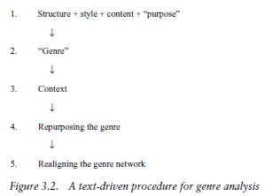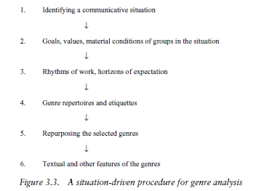

Table: Swales, J. (2004) Research Genres, Cambridge: CUP.

Communicative purposes in Oxford Reference encyclopedia
https://www.oxfordreference.com/view/10.1093/oi/authority.20110803095627947#:~:text=Schramm%20lists%20four%3A%20to%20inform,to%20narrate%20(see%20narration).

