Language Pedagogy: Literature Notes
- Schmitt’s (2020) Second Language Acquisition vs. Second language Learning
- Second language research: focuses on the developing knowledge and use of a language by children and adults who already know at least one other language.
- Theoretically: focuses how languages are represented in the mind, the difference between the way a language is acquired and processed.
- At the practical level, it focuses on how languages are learned: effective teaching practice.

How do we learn language?
- B.F. Skinner: behaviourism, habit formation, imitation, repetition
- Noam Chomsky: theory of innateness, universal grammar, language acquisition device. Children have an innate language faculty called ‘language acquisition device’: a set of principles (Universal Grammar). ‘Logical Problem of language Acquisition’: is that children learn language at a time in their cognitive development by they face a difficulty in grasping other kinds of knowledge

- According to Krashen, there is a ‘critical period’, after this period, children cannot acquire the target language (the second or foreign language): ‘the critical period hypothesis’.
- Age: After puberty, we cannot acquire native like competence.
- Neurological factors: the brain looses its plasticity and lateralization is accomplished (Scovel, 1969).

- Stephen Krashen’s hypotheses:
  - Acquisition-learning hypothesis (difference between language acquisition and language learning)
- Language Acquisition: gradual development of a language which occurs in a natural communicative setting.
- Language learning: is a conscious process of accumulating knowledge of vocabulary and grammar. This happens in a formal setting (institutional setting: schools/ classrooms).
  - Monitor hypothesis (adults use a monitor to correct their own speech): suggests that the acquired system may be used a monitor to edit speech.
  - Natural order hypothesis: we acquire grammatical structures in a pre-determinant ‘natural order’ (some are acquired earlier than others): the order of structures is not determinant by their simplicity and is independent of the order in which structures are taught.
  - Input hypothesis (comprehensible input): L2 learning occurs as a result of exposure to meaningful and varied linguistic input.
  - Affective filter hypothesis: influence through emotions (stress, fear, anger etc.), motivation is necessary for successful acquisition.
  - Interactional perspective: language learning takes place through social interaction. According to Krashen, interaction improves comprehension and comprehension allows acquisition.

Schmitt, N. (2010). An Introduction to Applied Linguistics (2nd ed.) Hodder Education.

- Freeman’s (2012) A Short History of ELT
Larsen Freeman, D. (2012). From unity to diversity: Twenty-five years of language-teaching
methodology. English Teaching Forum, 2, pp. 28-38.

- Different methods of language teaching
  - Grammar translation method
- Translating from the target language into the native language and vice versa (no communication skills involved).
- Classes taught in L1: learners memorize grammar rules and apply this knowledge to the task of translating sentences and texts.
- Language as a system
- Deductive approach to teaching (from rules to texts)

  - The Reform Movement:
- Movement spread in Europe: classes are taught in the target language
- Primacy of spoken language, they focused on phonetic scripts for beginners
- Connected text, inductive approach (from texts to rules), monolingual L2 classroom.

  - Direct method:
- Teaching takes place in the target language only
- Berlitz in the 19th C. This method came as a reaction to the grammar translation method.
- The objective: oral communication/ oral interaction
- Monolingual
- Grammar left out to self-study.

  - Reading method: focussed on the vocabulary proposed by West in the UK and the principle of this method is the management of vocabulary when the difficult words are substituted.

  - Audiolingual method (Army Method): based on behaviouristic view of language, focus on pronunciation, memorisation. It appeared when the US entered in the Second World War: there was a need for fluent speakers for foreign languages
Approaches: theory of language: structural linguistics (language is viewed as a structurally related elements)
Theory of learning : behavioural psychology (habit formation).
Objectives : oral proficiency (accurate pronunciation and grammar)
Syllable : is derived from contrastive analysis
Types of activities : dialogues, drills (minimal pairs)
PPP (presentation, practice and production)

  - Humanistic approaches:
- The Silent Way: developed in the 1960s by Gattegno. It is based on the belief that students should learn independently from the teacher/ independent language learner/ the teacher remains silent.
- Suggestopedia: Georgi Lozanov
- Helps learners eliminate psychological barriers to learning.
- Teachers create a positive, relaxed environment
- Teacher has authority
      - Community language learning: developed by Charles Curran in 1911. It focuses on cooperation and reflection. It is based on the assumption that learns learn best when they have a choice in what they are learning. A positive community learning.
      - Total Physical Response: developed by James Asher in 1970. It is based on the coordination between speech and action. Teaching language through physical activities to reduce stress, build/increase self-confidence.
  - Communicative approach: language is communication rather than a system
  - Eclecticism: based on the selection of good points from each method
It combines techniques and principles from various methods in a carefully manner.
Goal: prepare students to communicate
Develop their strategic competence
Develop learning strategies

3. Dörnyei’s (2009) Communicative Language Teaching in the 21st century
- Communication: activity which includes expressing ideas, feelings or giving information
- Language: system of communication used by people, can be spoken or written forms
- Communicative Language Teaching as opposed to other ELT methods (e.g. Grammar-translation method, audio-lingual method):
  - language is perceived as communication (as opposed to a system)
  - notional-functional syllabus (as opposed to a grammatical and lexical syllabus)
  - Learning the L2 by using it (instead of through drilling)
- Communicative competence: term coined by Dell Hymes (1972)
  - Functional knowledge of language use
  - Knowing the rules of language use, not just the grammatical rules (opposition to Chomsky’s linguistic competence)
- Four components of communicative competence:
  - Grammatical competence: knowledge of lexical items and rules of grammar, morphology etc. (Canale and Swain 1980)
  - Sociolinguistic competence: mastery of sociocultural rules, politeness, social context
  - Discourse competence: ability to combine language structures into different types of discourse (cohesion + coherence), interpretation individual message
  - Strategic competence: knowledge of strategies to overcome difficulties (e.g. repair strategies, hesitating, turn-taking …)

Dörnyei, Z. (2009). Communicative Language Teaching in the twenty-first century: the 'Principled Communicative Approach'. In: Psychology of Second Language Acquisition. Oxford: OUP. Seven principles by Dörnyei (p. 41)

Communicative language teaching was introduced in the 1970 as a counter reaction to the audiolingual methods. The goal on this method is to develop communicative L2 competence. L2 interaction in a communicative situation. Communicative competence: refers to knowledge and skills that enable a person to communicate.
The basic principles of CLT (Dörnyei):
- Teach communicative competence: grammatical competence plus the ability to use grammar appropriately
- Practise functions and forms in context-rich environment
- Make sure there are genuine needs, genuine partners and information gaps
- Give priority to fluency over accuracy
- Adopt a learner-centered attitude (PPP): Teacher regards students as partners
- Teacher roles change in 3 stages
  - Presentation stage : act as informant
  - Practice : a conductor
  - Production : a guide or co-communicator

  - Long’s (2009) Skills-based vs. Task-based Language Teaching
Long, M.H. and Doughty, C.J. (2009) The Handbook of Language Teaching. Blackwell.
- Skills-based language teaching
- The four basic skills:
  - Receptive skills: Listening and reading
  - Productive skills: Speaking and writing
- Subskills of these four skills
  - Reading sub-skills: skimming (general information), scanning (specific information), close reading (reading for pleasure).
  - Listening sub-skills: listening for gist, listening for information
Tasks: comprehension questions, yes/no questions, matching, gap filling, multiple choice questions...
  - Speaking sub-skill: Accuracy: vocabulary, pronunciation and grammar.
Fluency: interactive strategies (asking and answering), using repairing strategies: paraphrasing, clarifying... using everyday expressions...
  - Writing sub-skill: visual skills (spelling, punctuation..), grammatical skills: a range of structures, cohesion, coherence, lexical items, vocabulary resources... organization skills (structure of writing), rhetorical skills (connecting ideas..)
Tasks: writing ads, letter, brainstorming...
- The four skills are hardly separated in everyday life
- Not much sense to teach them in isolation: integration of the four skills

- Task-based language teaching (Skehan and Ellis): task based instruction (pre-task, while-task and post-task)
- Basic principle: we focus on the use of authentic language, students are to use meaningful tasks using target language
  - Focus on meaning rather than form
  - Tasks should have some kind of communicative gap
  - Choice of linguistic resources needed to complete the task (should be linked to real communication)
  - The tasks should have a clearly defined non-linguistic outcome

Definitions of task: Task is “a piece of classroom work which involves learners in comprehending, manipulating, producing or interacting in the target language while their attention is primarily focused on meaning rather than form” (Nunan (1989).

Long (1991) defines tasks as work plans that provide learners with the materials they need to achieve an outcome specified in communicative rather than linguistic terms. Ellis (2003) has added his own concise definition and pointed out that “tasks are activities that call for primarily meaning-focused language use” (p. 3).

Furthermore, Ellis (2003, pp. 9-10) has identified the critical features of a task:
- A task is a workplan
- A task involves primary focus on meaninghA task sas some kind of gap (=communicative problem that needs to be solved)
- A task involves real-world processes of language use
- A task can involve any of the four language skills
- A task engages cognitive processes
- A task has a clearly defined communicative outcome

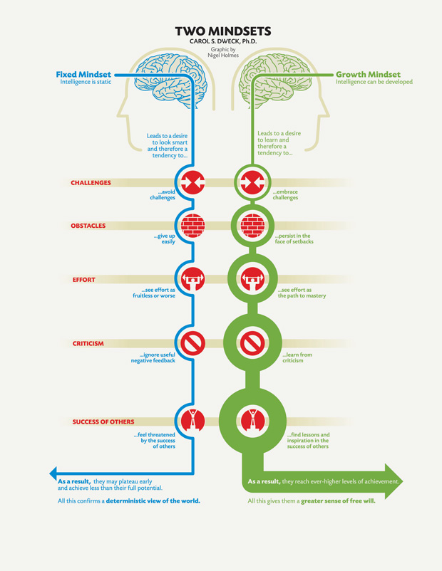
  - Mindsets and Motivation
- Carol Dweck
- Failure and effort
- Fixed vs. Growth mindset
  - Fixed mindset: focuses on competences, avoid challenges, goal oriented (often perfectionist), showing performance, stick to known strategies, effort as deficient ability, leads to diminished motivation. They are afraid of failure
  - Growth mindset: focuses on development, stand up to challenges, success is showing development, experiment with new strategies, effort as an ability to succeed, leads to enhanced motivation, failure is a motivation.

- Motivation: “a force that drives people to persue certain goals”: the choice of a particular action, the persistence with it and the effort expended on it.
- Motivation: intrinsic and extrinsic factors
  - Intrinsic: coming from within, pleasure in learning
  - Extrinsic: reward from outside (e.g. money, grade, praise)
  - Intrinsic motivation is more powerful, but extrinsic motivation is more prevailing
- Other kinds of motivation: integrative and instrumental motivation
  - Integrative motivation: trying to measure how open learners are to the culture of the target language
  - Instrumental motivation: motivation in order to achieve a goal
  - Pre-actional stage/Choice motivation: learners’ confidence to persue a task: “linguistic confidence”
  - The actional stage/Executive motivation: the quality of the learning experience, autonomy, self-determination: increase students’ involvement and commitment.
  - The post-actional stage/Motivation retrospection: learners’ final analysis and evaluation of things went.
Motivation in education: teachers’ motivational influence, the motivational characteristic of the curriculum, learner-specific motives (self-confidence, self-esteem)

How to motivate learners?
Establishing rapport with students/ increase the learner success/ setting specific goals, protecting learners’ confidence, self-esteem, create learner autonomy, provide motivational feedback.

6. Focusing on the Learner: Individual Differences
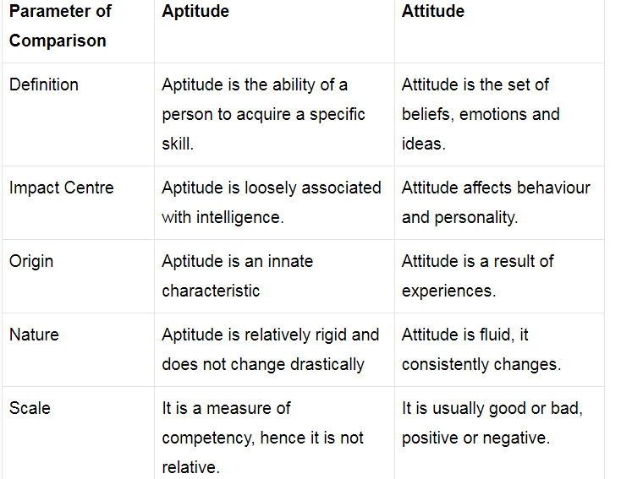
Dörnyei, Z. & Skehan, P. (2003) Individual Differences in Second Language Learning. In C. J.
Doughty & M. H. Long (eds.) The handbook of second language acquisition (pp. 589-630).
Oxford: Blackwell.

Language Aptitude: refers to the capacity and quality of learning. Modern Language Aptitude Test (MLAT) by Carroll and Sapon (1959)

Cognitive and learning style:
Learning Style means a habitual cross-situational use of a class of learning strategies
Cognitive style: predisposition to process information in a characteristic manner/ is restricted to information processing
- Learning style: a preference for approaching learning/ focuses on all aspects of learning: (6 aspects): cognitive: habitual patterns of mental functioning. Executive: the degree to which the person seeks order, manage the learning process. Affective: values, beliefs, and attitudes. Social: involvement with other people. Physiological: based on person’s anatomically based sensory and perceptual tendencies.
Behavioral: to satisfy learning preference.
Language learning strategies means the effectiveness of his/her own learning in the field of second language. It refers to sequence of procedures for accomplishing learning. Language learning strategies are divide into 4 items:
  - Cognitive strategies (e.g. repetition, summarizing, using images)
  - Metacognitive strategies (e.g. planning, evaluation, organising one’s own learning process)
  - Social strategies (e.g. interaction with peers)
  - Affective strategies (taking control of emotional conditions and experiences)

- Self-regulatory learning: Self-regulatory learning (learner specific perspective) = the degree to which individuals are active participants in their own learning; it is more dynamic concept than learning strategy. It seems that learning strategy had been replaced by the superhuman person of the self-regulating learner. Self-regulation is a very active field of research in educationl a psychology with new paradigm, researcher attempt to apply learner-initiated cognitive, metacognitive, and motivational process and strategies.

3) Motivation (see Carol Dweck)
Mercer, S. (2008) Learner self-beliefs. Key concepts in ELT. ELT Journal, 62/2, 182-183.
Different self-constructs:
  - Self-esteem: related to an individual’s value system
  - Self-efficacy: expectancy beliefs
  - Self-concept: an individual’s self-perceptions
Rose, H. (2012). Language learning strategy research: Where do we go from here? Studies in Self-Access Learning Journal, 3(2), 137-148.

7. Focusing on the Teacher: Changing Roles
Underhill, A. (1996) Facilitation in Language Teaching. In: Arnold, J. (ed.), Affect in Language
Learning. pp. 125-141.
- Three different kinds of teachers:
  - Lecturer: knowledge of the topic but no special skills in teaching.
Learning is a matter of exposure to the topic. Lack of flexibility in the teaching which makes difficult to respond to students’ interests, needs, styles. No systematic way of checking learning, getting feedback and diagnosing learning difficulties. No conceptual framework to encourage the development of such strategies. The main qualification is the knowledge of the topic. There is vertical development: to think about teaching methods and techniques.
  - Teacher: knowledge of the topic and familiar with methods (practical skills).
Main qualifications: knowledge of the subject matter and teaching methods. But there is no interest in developing personal and interpersonal classroom skills. There is no systematic intention to develop learner self direction and self evaluation. Vertical development: awareness of psychological atmosphere of the class.
  - Facilitator: knowledge of the topic, familiar with methods and actively pays attention to the learning atmosphere (practical skills + sensivities)
Main qualifications: knowledge of the subject matter, skilful use of teaching
Methods and capacity to generate a psychological learning atmosphere: the relationship in and between people in the group, the degree of security, the quality of listening and acceptance.
Practical steps towards facilitation: feelings, attitudes, thoughts, degree openness, quality of attention.
Listening: the way the teacher listens: notice how they listen, what takes their attention, deepen the attention in a supportive and respectful way.

8. Group Dynamics
Dörnyei Z., & Malderez, A. (1997). Group dynamics and foreign language teaching. System, 25/1, 65–81.
- Group: “resource pool”, more resources than a single member (Douglas 1983)
- Group dynamics: focuses on the scientific analysis of the behaviour of small groups.
- The benefits of groups: source of motivation to learn the L2, provide guidelines, standards for evaluating ourselves, facilitates L2 learning...
- The importance of group dynamics.
  - Group formation: Intermember relations: the initial attraction towards others (sharing personal information), Acceptance: feeling towards other individuals.
  - Group norms: are rules or standards that describe the behaviours/ to become group’s value system: They formulate norms, justify their purposes, discuss them, agree on them. Ice-breakers and warmers: classroom activities to get members to memorize each others’ names, learn about each other, establish personal relationship.
- Different phases in the development of groups (FoSNoPerA)
  - Forming: develop attraction bonds between the members.
  - Storming: is characterized by disagreements, conflicts, competition to increase cohesion and cooperation.
  - Norming: establishing norms to regulate behaviours. (e.g., applying such rules to the member)
  - Performing (phases 2 and 3 can also be summed up as “maintaining”): is characterized by increasing cooperation: the group has reached maturity.
  - Adjourning / mourning aka dissolution or disbanding: group ending

Group characteristics:
- Norms
- Status system: each member occupies a certain position.
- Group cohesion: relationship linking the members of to one another.
- Classroom goal structure: how the members contribute to achieving the goals of the group.
- Group dynamics influence the lesson and the way of teaching
- The Teacher as a group leader

The effect of the physical environment on the group:
- Arrangement of the chairs: sitting in a circle fosters interpersonal attraction and involvement.
- Semi-circle: (U-shape) (It depends on the classroom activities: games, small group activities..)
- The lack of chairs: create a feeling of closeness and personal communication.
- Personalizing the classroom: nice decoration creates a better, a more human relaxed atmosphere.

The role of the teacher:
- Facilitates, creates the right conditions for development
- A teacher as a facilitator
- Promotes classroom interactions using techniques, forms of classroom organization
- Allows members to know each other.
- Uses pair work/ group work
- Formulates group norms.
- Deal with conflicts openly
- Encourage students autonomy
- Share the ownership of the classroom with the group.
- Above all, it is important in the group dynamics that the teacher is a facilitator.

9. Brown’s Assessment and Feedback
Brown, H.D. (2001). Basic Concepts in Test Development. Chapter 21 In: Teaching by Principles. New York: Pearson Longman.
- Handout on Assessment
- Types and aims of tests
- Alternative assessment
- Aims of assessment
Assessment means measuring a person’s ability or knowledge in a given domain. E.g., Assessing (aptitude) performance/ competence. In a given domain: a pronunciation might be a test only for a particular sounds, phonemes.

The aims of assessment
- To help the teaching’s planning of classroom work (formative and summative assessment)
- To focus on mistakes, difficulties..
- To motivate, encourage learners
- To give feedback
- To give grades
- To help learners assess their own progress (self assessment)
- To keep track of learners’ progress (continuous assessment).

- Criteria of a good test:
  - Practicality: the test has to be practical regarding financial limitations, time...
An expensive test is impractical/ a test of a language proficiency that takes a students ten hours to complete is impractical.
norm-referenced vs. criterion-referenced
- norm-ref.: score interpreted in relation to a mean
- criterion-ref.: designed to give test-takers feedback on specific criteria (objectives) of the course
  - Reliability: consistency
    - Test reliability: the same test produces a consistent score
    - Scorer reliability: the same scorer produces a consistent score
  - Validity: test measures what it is intended to measure
    - Content validity:
    - Face validity: students belief that the test measures what it is supposed to measure
    - Construct validity: deals with the construct of the test, test is formed on the basis of the syllabus, for example; the syllabus meets the purpose of the test

- Types of tests:
  - Proficiency tests: to measure and compare students’ global competence in a given language or other subject.
  - Diagnostic tests: to diagnose a particular aspect of a language. For example, test in pronunciation has the purpose of determining which phonological features of English are difficult for a learner.
  - Placement tests: to place students into an appropriate level or section.
  - Achievement tests: to analyze the extent to which students have acquired language features that have been taught.
  - Aptitude tests: to measure a person’s capacity or general ability.
The Modern language Aptitude Test – different ability that we have may affect our language learning

Historical development in language testing: language assessment goes hand with hand with teaching methods:
- 1950s:Behaviourism: contrastive analysis
- 1970s-1980s: communicative theories of language: integrative view of testing
- Today: request for more authentic, content, valid instruments.

Alternative assessment
The content of test has become broader including more emphasis on sub-skills (reading: skimming, scanning)
The communicative approach: assess learners’ ability to extract meaning and convey messages.
Alternative assessment methods:
- Observation-driven assessment that focuses on both language and content.
- Portfolios (compositions, pictures, recordings, notes..)
- Learners’ personals diaries

10. Megyes’ NESTs and Non-NESTs
Medgyes, P. (2001). When the teacher is a non-native speaker. Teaching pronunciation, 429-442.
- Differences between NESTs and Non-NESTs:
  - Language proficiency (Non-NESTs tend to deem their language proficiency inferior to that of NESTs)
  - Teaching behaviour influenced by this perception
  - Both groups can be good teachers but there are differences
  - The NEST is a better language model but the Non-NEST is a better learner model
  - Ideology: NESTs often believed to be better models of English, one standard variety assumed, teachers from the Western world are privileged (cf. native-speakerism)

Who is the native speaker teacher?
- Linguistic perspective: speaks English as his/ her native language/ born in an English speaking country (Birth does not determine language identity).
- Educational perspective: proficient user of English
- The ownership of English: no longer the possession of native speakers/ it is the ownership of its users and speakers who speak English

Ideology of native-speakerism: language ideology
- Assumes that the ultimate model for languages in the Native speaker model
- Insist on ‘proper’ grammar in the name of effective communication
- Assumes a standard variety
- Privileges teachers from the English speaking West (coursebooks, methods..)

Non-native speaker teachers:
- A teacher for whom English is a second/ foreign language
- Who works in English foreign language environment
- Whose students are monolingual
- Who speaks the same native language as his/her students

The differences: in terms of language proficiency and teaching behaviour
Native speaker teacher | Non-native speaker teachers
- Speaks better English  - Fluency  - Focuses on meaning  - Use real English  - Use English more confidently  - Adopt a more flexible approach | - Speaks a poorer English  - Accuracy  - Forms  - Use bookish English  - Use English less confidently  - Adopt a more guided approach

Benefits of Non-native speaker teachers
  - Provide a better learner model
  - Teach language learning strategies more effectively
  - Supply more information about the English language
  - Better anticipate and prevent language difficulties
  - Be more sensitive to their students
  - Benefit from their ability to use the students’ native language

