BMNEN04400M, BNY-DK-200A
Academic English
Reményi October 04, 2019

Vocabulary practice Units 1, 40-41, 30-31

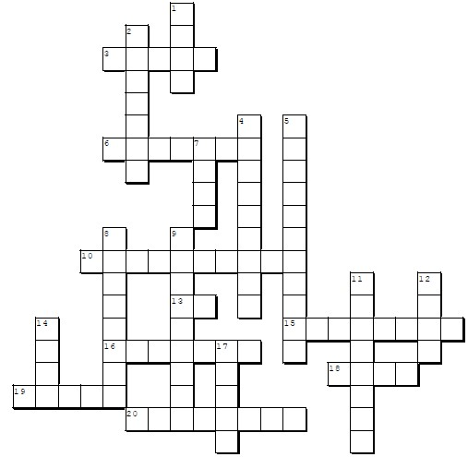
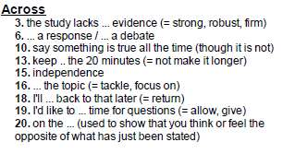

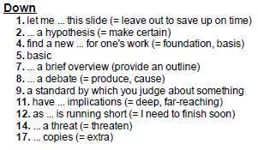

Vocabulary practice Units 1, 40-41, 30-31, 32-33 Send your solutions by Tuesday October 8 for the key in return.
I. Matching gapfill task: look for the same single word filling all the gaps in the six sentences in the set.
1. Many people ............ their self-worth from their work. I didn't ............ much benefit from school.
She ............ great satisfaction from helping other people. The charity ............ its income entirely from donations.
He ............ an enormous amount of satisfaction from restoring old houses. The institute ............ all its money from foreign investments.

2. Ionizing radiation can cause the destruction of microorganisms and insects involved in food spoilage or, at lower doses, can
.......... their action.
Teaching methods, learning material, and promotion policies may ............ learning and lead to maladjustments for some children. It will, however, ............ the sprouting of potatoes and other root vegetables.
Some workers were ............ed (from speaking) by the presence of their managers. The drug is declared to ............ the growth of tumors.
The good language learner has a strong drive to communicate, or to learn from a communication. The good language learner is often not ............. In addition to focusing on communication, the good language learner is prepared to attend to form (Rubin 1975, 46)

3. If it was ............ , it was now also unnecessary, and whether or not, the outcome would be disastrous. Did you leave his name out by accident or was it ............ ?
Measurements of skins are of little value as every snake hide is noticeably longer than its carcass and ............ stretching presents no difficulty to the unscrupulous explorer.
I didn't ignore her ............ly - I just didn't recognize her.
Biological warfare is the ............ use of living microorganisms or their toxic products for the purpose of destroying or reducing the military effectiveness of man.
The ............ act or psychological mode of a thought is the particular kind of mental event that is, whether this be perceiving, believing, evaluating, remembering, or something else.

II. Write a definition and a clarifying example sentence for each of these items: autonomy, generate a debate, trigger (V), in-depth, unearth

Hw. 1. Cover Units 32-33. 2. Solve & send the solutions of the above Exercises I-II and Exercise III overleaf by Oct 8 to my email.

Topic sentences

Find the topic sentence for each of these paragraphs by matching the paragraph numbers with the topic sentence letters.

JENNY CHESHIRE: FITTING IN TO A NEW HOME – WITH A BRI’ISH ACCENT?

1 ............................................................................................................................................................................ Devyani Sharma and Lavanya Sankaran, however, found that the phenomenon is more complex than this – language change between different generations is more gradual than might be expected, and it is also more complex.
2 ............................................................................................................................................................................ There, over the course of the last 60 years, South Asians have shifted from being a minority group to a majority one which now makes up more than 60 per cent of the local population.The researchers analysed the English of three groups of South Asians, totalling 42 individuals. One group consisted of first generation immigrants who had migrated from India as adults, and the two other groups were locally-born second generation South Asians, one older (aged between 35 and 60) and one younger (aged between 18 and 35). The older second generation group had grown up in Southall at a time when South Asians were still a minority group there and when race relations in the area were hostile. By the time the second, younger, group (aged 18-35) was growing up, South Asians were no longer such a minority in Southall and, perhaps as
a result, race relations had shifted to a cooperative coexistence.
3 ............................................................................................................................................................................ The local London pronunciation of /t/ is glottalised (with the pronunciation of words like water or feet sometimes represented in popular writing as wa’er and fee’). As you might expect, the first generation South Asian speakers had almost no glottalised pronunciations of /t/. By contrast, both second generation groups used glottalised /t/; furthermore, they followed the same pattern, using this pronunciation more often at the end of a word than the middle of a word (so,
more often in feet than water). In their use of glottalised /t/, then, those in the second generation were speaking more
like locally-born people of their age than their parents – just as we might expect.
4 ............................................................................................................................................................................ Here the tip of the tongue is curled back to touch the ridge just behind the top teeth (or close to the ridge). You can hear this pronunciation in the stereotyped English of Apu, the Indian immigrant in The Simpsons. The first generation immigrant group used retroflex /t/ 35 per cent of the time. The second generation groups also used this pronunciation, albeit less often: 16 per cent of the /t/’s in the English of the older second generation were retroflex, and 8 per cent in the English
of the younger speakers. The second generation, then, had not altogether abandoned the pronunciation of their parents: although language change was taking place across the generations in these immigrant families, it was a more gradual process than is often supposed.
5 ............................................................................................................................................................................ Unlike both their parents and the older second generation group, the younger speakers used retroflex /t/ more often at the beginning of a word, where it is more salient (for example, in tea or toffee). They also pronounced it with a “fortis” (more energetic) phonetic quality.
6 ............................................................................................................................................................................ Even here, though, the picture is more complicated than this gender difference suggests. Female speakers used a surprisingly high number of pronunciation features influenced by Punjabi, including retroflex /t/, when they were speaking English at home. For female speakers, then, there seems to be a sharper compartmentalisation of styles across their repertoire.

Topic sentences:
A The researchers focussed on the pronunciation of /t/, which has a distinctive local pronunciation as well as a South
Asian pronunciation.
B Sharma and Sankaran worked in the Punjabi community in Southall, London. C The change was also more complex than expected.
D However, the South Asian speakers sometimes pronounced /t/ as a retracted or retroflex consonant, as in Punjabi, the
Indian language that they also spoke.
E In interviews with the researchers younger second generation male speakers used retroflex /t/ more often than younger female speakers.
F It is often thought that as they grow up, the children of immigrants begin to sound like their locally-born friends rather than their parents.

