HANS ROSLING (2006): The best stats you’ve ever seen
A TED talk (recording: 20 mins, your work: 60-90 mins)

YOU CAN EITHER PRINT THIS WORKSHEET, AND WRITE YOUR RESULTS DIRECTLY INTO THE PRINTOUT, OR YOU CAN WORK ON IT ON THE SCREEN, BUT THEN YOU HAVE TO HAVE ANOTHER WINDOW OPEN FOR THE VIDEO.
Open this page in your browser: http://www.ted.com/talks/hans_rosling_shows_the_best_stats_you_ve_ever_seen.html

Make sure you switch off the subtitles before you start watching the talk. It is OK if you re-watch the video a few times.
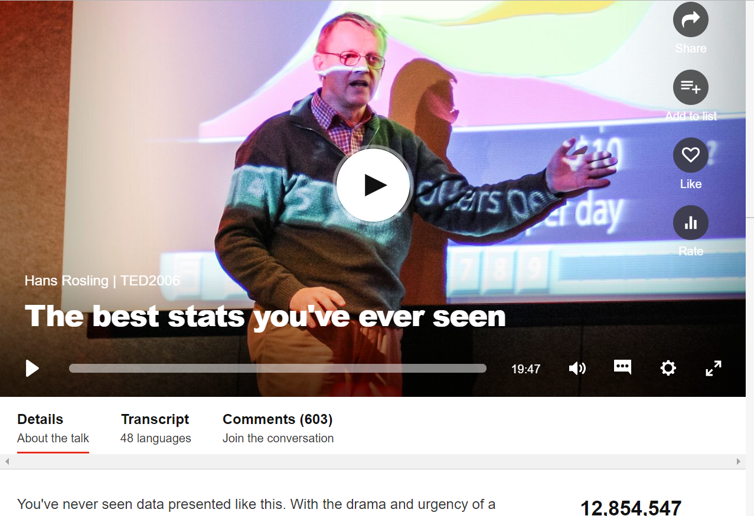
(Over 12 million views.)

Before you start the video, do these tasks.
1. The lecturer will discuss issues in global health. Which of these words/expressions do you think he will use?

child mortality
chimpanzees
ignorance
a preconceived idea
life expectancy
promote family planning
Let me make a comparison directly
give up communist planning
underestimate
display the distribution
country club
on that axis
trade barriers
health cannot be bought at the supermarket
famine
non-profit venture
mind the gap (London Tube)
pretty scary

Do you know the meaning of the ones you think will appear in the talk? Are you sure about them? If not, look them up.

2. Here you can test if you know the meaning of some of the above. Which of them have these meanings?

a. the most probable number of years of life remaining at a given age
b. starvation in large groups of people
c. a private group of well-to-do people spending their free time together
d. an opinion formed without adequate knowledge or experience
e. business restrictions

3. Which country has the higher child mortality between each pair? One in each pair has twice the child mortality of the other.

Sri Lanka or Turkey? ....................................
Poland or South Korea? ....................................
Malaysia or Russia? ....................................
Pakistan or Vietnam? ....................................
Thailand or South Africa? ....................................

While you are watching the video, do these tasks.
Try to make sense of the following questions discussed in the first part of the talk. First read the questions, and only then push the Play button.

4. Why is the audience laughing when Gosling says “there was a place for a professor of international health and for my course”? . . . . . . . . . . . . . . . . . . . . . . . . . . . . . . . . . . . . . . . . . . . . . . . . . . . . . . . . . . . . . . . . . . . . . . . . . . . . . . . . . . . . . . . . . . . . . . . . . . . . . . . . . . . . . . . . . . . . . . . . . . . . . . . . . . . . . . . . . . . . . . . . . . . . . . . . . . . . . . . . . . . . . . . .
5. When he compares Karolinska Institute professors with chimpanzees, what is the result? . . . . . . . . . . . . . . . . . . . . . . . . . . . . . . . . . . . . . . . . . . . . . . . . . . . . . . . . . . . . . . . . . . . . . . . . . . . . . . . . . . . . . . . . . . . . . . . . . . . . . . . . . . . . . .
6. What does each bubble indicate in the first graph? . . . . . . . . . . . . . . . . . . . . . . . . . . . . . . . . . . . . . . . . . . . . . . . . . . .
7. Why does he examine the relationship between the fertility rate (the horizontal axis) and life expectancy (the vertical axis)? How does this relate to what his students have responded? . . . . . . . . . . . . . . . . . . . . . . . . . . . . . . . . . . . . . . . . . . . . . . . . . . . . . . . . . . . . . . . . . . . . . . . . . . . . . . . . . . . . . . . . . . . . . . . . . . . . . . . . . . . . . . .. . . . . . . . . . .
8. How does he define ‘fertility rate’ in his talk? . . . . . . . . . . . . . . . . . . . . . . . . . . . . . . . . . . . . . . . . . . . . . . . . . . . . . . . . . . . . . . . . . . . . . . . . . . . . . . . . . . . . . . . . . . . . . . . . . . . . . . . . . . . . . . . . . . . . . . . . . . . . . . . . . . . . . . . . . . . . . . . . .
9. What turns out to be the relationship between the fertility rate and life expectancy across time, as is shown by the dynamic graph? . . . . . . . . . . . . . . . . . . . . . . . . . . . . . . . . . . . . . . . . . . . . . . . . . . . . . . . . . . . . . . . . . . . . . . . . . . . . . . . . . . . . . . . . . . . . . . . . . . . . . . . . . . . . . . . . . . . . . . . . . . . . . . . . . . . . . . . . . . .. . . . . . . . . . . . . . . . . . . . . . . . . . . .
10. What do the colour codes mean? Red for . . . . . . . . . . . Green for . . . . . . . . . Yellow for . . . . . . . . . . . . . . . . . . .
11. Why does he say “the concept of ‘developing countries’ is extremely doubtful” at the second graph (income distribution)? . . . . . . . . . . . . . . . . . . . . . . . . . . . . . . . . . . . . . . . . . . . . . . . . . . . . . . . . . . . . . . . . . . . . . . . . . . . . . . . . . . . . . . . . . . . . . . . . . . . . . . . . . . . . . . . . . . . . . . . . . . . . . . . . . . . . . . . . . . . . . . . . . . . . . . . . . . . . . . . . . . . . . . . . .
12. According to the third graph, what relationship is shown between child survival and GDP per capita? . . . . . . . . . . . . . . . . . . . . . . . . . . . . . . . . . . . . . . . . . . . . . . . . . . . . . . . . . . . . . . . . . . . . .. . . . . . . . . . . . . . . . . . . . . . . . . . . . . . .

Now you can push the Play button. Stop the recording at 11:33, and go back to questions 4-12.

When you have finished answering the above questions, try to make sense of the following questions discussed in the second part of the talk. First read the questions, and only then push the Play button.

13. What is his argument against discussing solutions to find to support Africa? . . . . . . . . . . . . . . . . . . . . . . . . . . . . . . . . . . . . . . . . . . . . . . . . . . . . . . . . . . . . . . . . . . . . .. . . . . . . . . . . . . . . . . . . . . . . . . . . . . . . . . . . . . . . . . . . . . . .
14. How does he describe the present state of using publicly funded databases? . . . . . . . . . . . . . . . . . . . . . . . . . . . . . . . . . . . . . . . . . . . . . . . . . . . . . . . . . . . . . . . . . . . . .. . . . . . . . . . . . . . . . . . . . . . . . . . . . . . . . . . . . . . . . . . . . . . . . . .
15. Why is his project called Gapminder? . . . . . . . . . . . . . . . . . . . . . . . . . . . . . . . . . . . . . . . . . . . . . . . . . . . . . . . . . . . . . . . . . . . . .. . . . . . . . . . . . . . . . . . . . . . . . . . . . . . . . . . . . . . . . . . . . . . . . . . . . .. . . . . . . . . . . . . . . . . . . . . . . . . . . . . . . . .
16. How does he sum up the message of his talk towards the end? . . . . . . . . . . . .. . . . . . . . . . . . . . . . . . . . . . . . . . . . . . . . . . . . . . . . . . . . . . . . . . . . .. . . . . . . . . . . . . . . . . . . . . . . . . . . . . . . . . . . . . . . . . . . . . . . . . . . . .. . . . . . . . . . . . . . . . . .

Now you can push the Play button. Watch the recording up to the end, and go back to questions 13-16 afterwards.

There is one more question remaining at the end.

17. Do you know where I’ve found this?

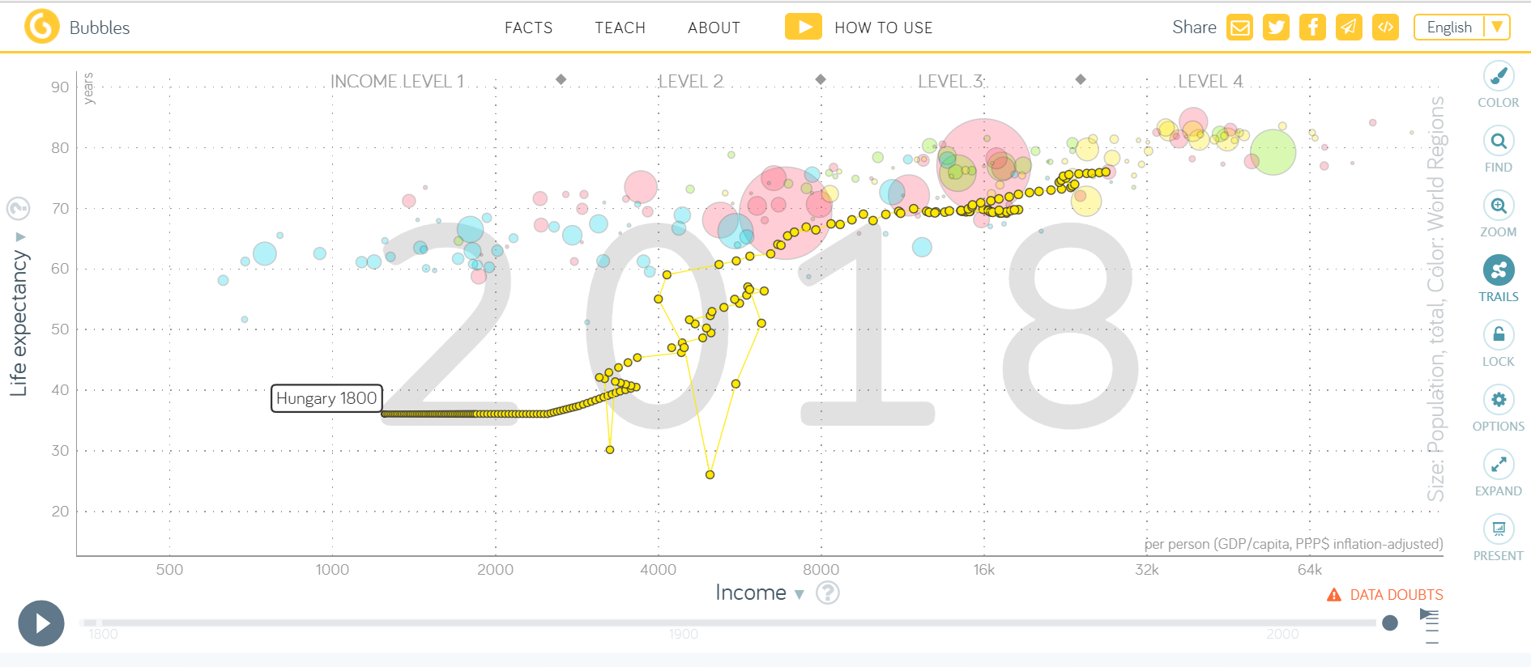

Find the webpage yourself. How can you get to it? Copy the full link here.

