Syntax Assignments – Diagram Tree

Dedy Subandowo

GPS 1 2/3

1. very smelly

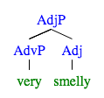

1. too quickly

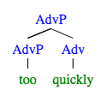

1. much too quickly

AdvP “much” is sister to Adv ”too”

AdvP “much too” is sister to Adv “quickly”

GPS 2 3/4

1. the desk with the wobbly drawer: D, N and PP are sisters

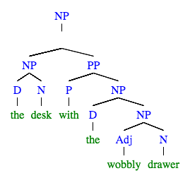

1. in my black rubber boots

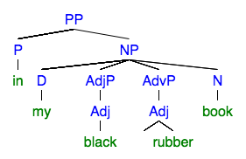

GPS 4 3/3

1. snores



1. eats burgers

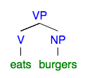

1. always smokes in the car

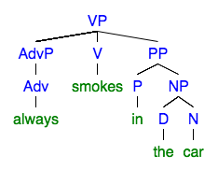

GPS 6 6/6

1. the Kangaroo hopped over the truck

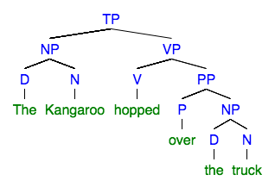

1. I haven’t seen this sentence before

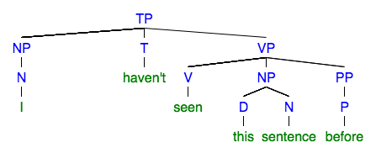

### Susan will never sung at weddings

