Syntax Assignments – Diagram Tree

Dedy Subandowo

GPS 1

1. very smelly

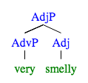

1. too quickly

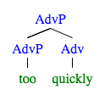

1. much too quickly

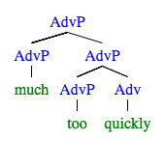

GPS 2

1. the desk with the wobbly drawer

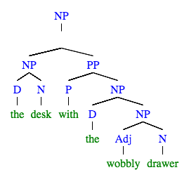

1. in my black rubber boots

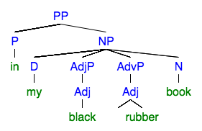

GPS 4

1. snores



1. eats burgers

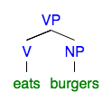

1. always smokes in the car

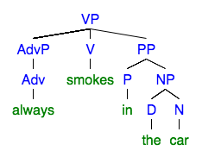

GPS 6

1. the Kangaroo hopped over the truck

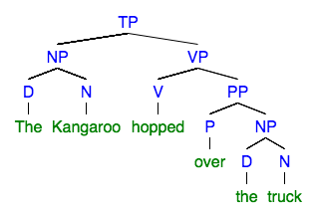

1. I haven’t seen this sentence before

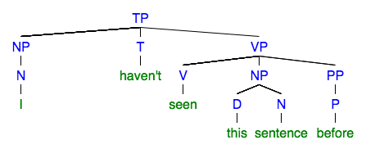

### Susan will never sung at weddings

