Dedy Subandowo
Exam Sheet
Syntax BNY-DK-001A
2021 June 4th, 10:15 to 11:45
Parts of Speech
1. Subcategories of Nouns: For each of the nouns below put a + sign in the box under the features that they have. Note that some nouns might have a plus value for more than one feature. The first one is done for you. Do not mark the minus (–) values, or the values for which the word is not specified; mark only the plus values!
Noun | plural | count | proper | pronoun | anaphor
mice | + | + | +
myself |  | + |  |  | +
we | + |  |  | +
Budapest |  | + | +
chair |  | + | +
water |  |  | +

Constituency, Trees, and Rules
2. Consider the sentence below. Prove with the help of the three constituency tests (replacement, stand-alone, movement) that the italicized part is a constituent:
a) Mary stayed at a luxurious hotel.
Replacement = Mary stayed there/here
Stand-alone= where is she? at a luxurious hotel.
Movement = at a luxury hotel, Marry stayed.

Constraining X-bar: Theta Theory
3. Thematic relations: Identify the thematic relations associated with each DP or embedded CP in the following sentences. Each DP or CP may have more than one thematic relation associated with it.
a) Jaime sang a song.
Jaime = Agent, theme, source
A song = goal,

b) It is snowing in Canada.
It = theme
In Canada = location

c) Mary hopes that John baked a nice cake for her.
Mary = Agent
John = experiencer, source
A nice cake = goal,
Her = beneficiery, recipient

Structural Relations
4. Domination: Study the following tree carefully and then answer the questions about it that follow:
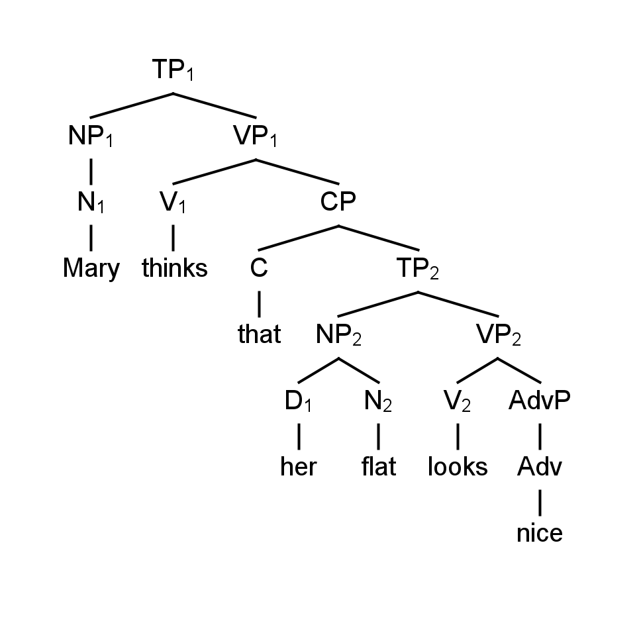
a) List all the nodes that dominate each of the following items:
NP₂: TP2
N₁: NP1
b) List all the nodes that are dominated by the following items:
VP₂: Tp2
C: CP
c) What is the root node? TP1

TEST CONTINUES: SEE NEXT PAGE
5. C-command: Study the following tree carefully and then answer the questions about it that follow:
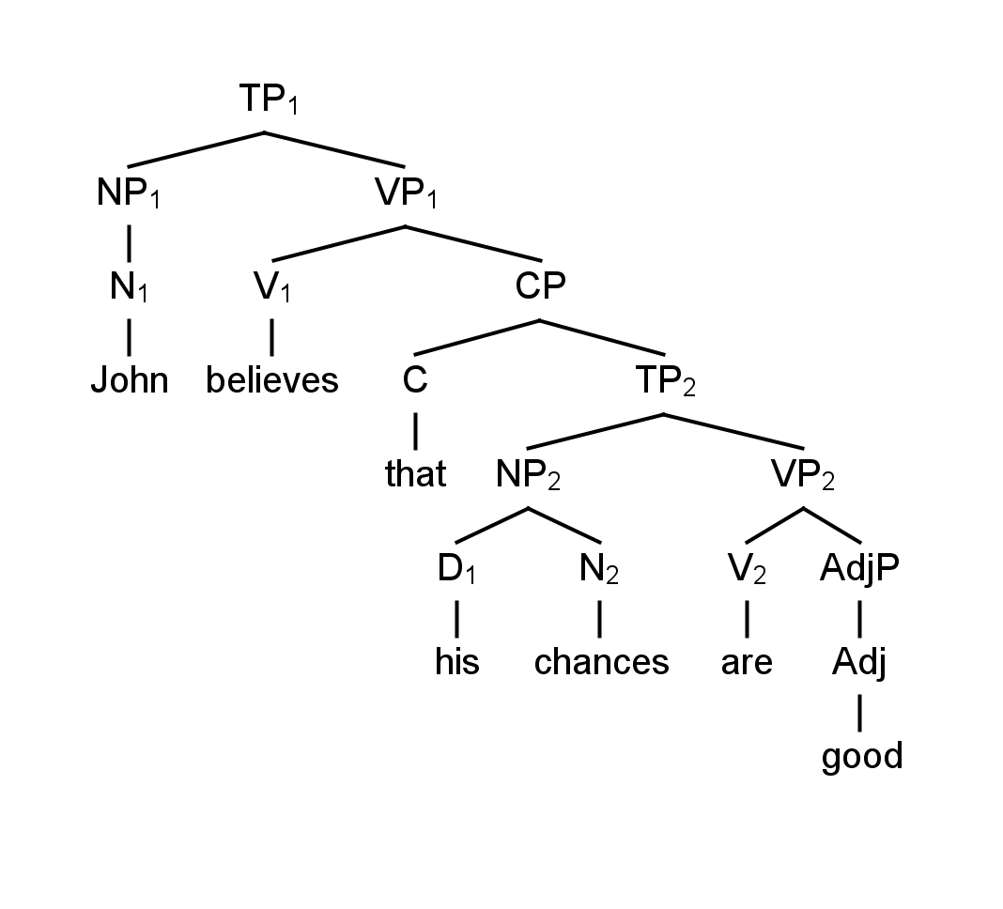
a) List all the nodes that are c-commanded by the following nodes:
NP₂: Vp2
D₁: N2
b) Which nodes c-command the following nodes:
TP₂: C
N₁: V1

Binding Theory
6. NP Types: Identify the type of NP (anaphor, pronoun, R-expression) of each of the following:
- his: peonoun
- themselves: anaphor
- each dog: R-expression
- one another: R-expression
- they: pronoun
- carol singing: R-expression

Binding principles
7. Explain why the following sentences are ungrammatical. For each sentence, say what the binding domain of the NP causing the problem is, whether it is c-commanded by its binder (antecedent), and name the binding condition that is violated.
a) *Mary_{i} loves her_{i}.
Mary = Binder
Bindee = her
Mary [antecedent] C-commands her [pronoun]
Her [pronoun] must be free
Binding principle B

b) *John thinks that Susan_{i} should kiss her_{i}.
Susan [binder]
Her [bindee]
C-commend but not the same index
Pronoun her must be free
Principle B

c) *He_{i} loves Jack_{i}.
Binder [He]
Bindee [Jack]
He c-commends Jack
R-expression must be free
Binding principle C

d) *Fred_{i}’s uncle_{j} loves him_{j}.
Anaphor must be free
Fred and Him are not coindexed
Binding principle A

e) *Michael_{i} thinks that Ann should marry himself_{i}.
Himself [anaphor] needs to find antecedent in the same clause
C-command but not coindexed
Principle A

X-bar Theory
8. Complements and Adjuncts: Using the tests discussed in Chapter 6, determine whether the PPs in the following NPs are complements or adjuncts. Give the examples that you used in constructing your tests. Some of the NPs have multiple PPs. Be sure to answer the question for every PP in the NP.
a) A box [of chocolate] = complement
*A [of chocolate] box

b) The picture [of my parents] [on the table]
[of my parents] = complement
*The picture [on the table] [of my parents]
[on the table] = adjuct
[On the table] the picture [of my parents]

c) A room [with a nice view] = complement, cannot be reordered
*[with a nice view] a room

7 Extending X-bar Theory to Functional Categories
9. Clause types: The following sentences are “complex” in that they contain more than one clause. For each sentence, identify each clause. Remember, main clauses include embedded clauses. Identify the complementizer, the T, and the subject of the clause; be sure to identify even null (Ø) complementizers and Ts with suffixes in them. State whether each clause is a finite clause or a non-finite clause.
a) John considers Syntax to be an interesting subject.
TP Main clause = John considers Syntax to be an interesting subject
TP embedded clause = Syntax to be an interesting subject
Subject = John (main clause), Syntax (embedded clause)
Non-finite clause
- no complementzier
b) Fred saw Helen driving a red sports car.
Tp main clause = Fred saw Helen driving a red sports car.
TP embedded clause = Helen driving a red sports car.
Subject = Fred [main clause], Helen [embedded clause]
Non-finite clause
No complementizer

c) Mary will know that the door is open.
TP main clause = Mary will know that the door is open.
TP subclause = that the door is open.
Subject = Mary [main clause], the door [embedded clause]
Complementizer = that + the door is open.
Finite clause

d) The captain had said for all passengers to remain seated.
TP main clause = The captain had said for all passengers to remain seated.
Tp subclause = all passengers to remain seated.
Subject = The captain [main clause], all passengers [subclause]
No-complementizer
Non-finite clause

9 Auxiliaries and Functional Categories
10. Tense, auxiliaries, aspect and voice: For each of the following sentences determine what tense it is in (if it has a modal auxiliary, you don’t have to identify the tense), whether or not it has a modal auxiliary, whether it is in the perfect, whether it is progressive or nonprogressive, and whether it is in the active or the passive voice.
a) Francis is reading.
Present progressive tense, active, auxiliary [is]

b) Francis must have read all the books.
Active, Modal auxiliaryy = must have

c) The books should have been read by Francis.
Passive, Modal auxiliary = should have

d) Francis might have been reading some interesting books.
Active, Progressive, Modal auxiliary = might have

10 Head-to-Head Movement
11. Verb-raising: Consider the following sentences from Haitian Creole. Is Creole a verb-raising language or not? Explain your answer.
a) Bouki deja konnen Boukinèt
Bouki already knows Boukinèt
“Bouki already knows Boukinèt.”

b) Bouki pa konnen Boukinèt
Bouki NEG knows Boukinèt
“Bouki doesn’t know Boukinèt.”
It seems that Haitin Creole is not is a verb-rising language because neither deja [adverb] nor Neg [negation] comes between the verb konnen and its complement Boukinet

